Taglish Product Review Understanding with Multilingual Transformers: Sentiment, Aspect, and Deception Analysis for Philippine E-Commerce (Automated Optimization)
Bharon Christopher P. Candelaria
Computer Studies and Engineering
Jose Rizal University
Mandaluyong City, Philippines
bharonchristopher.candelaria@my.jru.edu

Abstract— This is because this paper introduces a Taglig conscious system of interpreting product reviews under Philippine e-commerce. Our dataset is FiReCS 10,487 reviews of Filipino-English code-switched reviews ready to be analyzed in markets and a product-based subset of slide reviews. The strategy is a combination of three tasks within one workflow. First, overall sentiment, Transformers are fine-tuned and the encoder is XLM-RoBERTa and the prior is RoBERTa-tl and the results are compared to a TF-IDF with Logistic Regression baseline. Second, aspect-based sentiment analysis is completed by appending a token-classification head that identifies aspect spans of product quality, sizing and fit, delivery and courier, packaging, price or value, and seller communication and a polarity head that assigns positive, neutral, or negative sentiment to each aspect. Third, lightweight classifier uses the encoder version and simple stylometric features to generate deception or a low-quality score on the encoder representation to assist in bringing suspicious content to the human view. Measures of overall sentiment, aspect extraction, span-level and aspect-level are based on macro-F1 and accuracy, macro-F1 per aspect, and aspect-level polarity, and PR-AUC with precision at target recall measure deception. Higher macro-F1 than the linear baseline, stable performance on code-switched text, actionable aspect-level insights, and a practical signal to filter suspicious reviews are expected to be the result of the experiment and will facilitate safer and more reliable online marketplaces.
Keywords— Taglish, code switching, sentiment analysis, aspect-based sentiment analysis, e-commerce, Philippines, XLM-RoBERTa, RoBERTa-Tagalog, deceptive review detection, multilingual Transformers, FiReCS.

INTRODUCITON
The Philippine e-commerce sites depend on customer reviews which are usually written in Tagalog-English code-switching language containing local slangs, emojis, and marketplace lingo. Misreading These reviews are often misread by tools which are largely trained on monolingual English and fail to provide useful concerns which buyers and sellers are often interested in e.g. delivery speed, quality of packaging, size and fit, price to value and communication with the seller. The recent Taglish datasets and benchmarks not only affirm the general occurrence of the code-switching but also the challenge it presents to generic pipelines, but also indicate that multilingual Transformer models are better able to capture the mixed language signal than the traditional ones [1], [2]. Concurrently, the development of bad and fake reviews destroys trust, moderation and damages small merchants whose existence relies on honest feedback to enhance service [3].
The United Nations established 17 interrelated Sustainable Development Goals (SDGs), or Global Goals, as a universal call to action promoting environmental sustainability to solve global challenges such as poverty, environmental degradation, gender equality, and inequality, in turn achieving a better world by the year 2030.

Figure 1. Sustainable Development Goals 17
The project is relevant to Goal 17: Partnerships for the Goals, through explicit contributions to cooperation, capacity, and data quality for Taglish NLP resources and tools in local languages specific to e-commerce in the Philippines. The primary synergy with Target 17.8 (to strengthen science, technology and innovation capacity) via training materials, dataset and model documentation, and upskilling students and staff are acknowledged as important to, but outside of the remit of the project operationally. [4]-[6]. This study correlates to SDG 17 (Target 17.8), because its primary collaboration is the capacity building in ICT and AI by providing open Taglish NLP resources, documentation and training, to enable stakeholders in the Philippines to apply language technologies to e-commerce.
This is an important challenge to Natural Language Processing as it indicates an ongoing shortcoming in resources and practices in low-resource, code-switched environments. Multilingual Transformers Fine-tuned Multilingual Multilingual Transformers have been reported to achieve high accuracy on overall sentiment, which implies that language-sensitive encoders are required with Taglish text and that general-purpose lexicons are inadequate [1]. Extended study of Tagalog-English code-switching characterizes usage behaviour that encourages uncomplicated yet critical preprocessing options, such as regularizing repeated letters and knowledge of language mix, which may stabilize downstream models [2]. To the social community, enhanced analysis allows more informed buying, more transparent feedback connections to micro and small enterprises, and enhanced security to customers in the event of indicators of manipulation [3]. The implementation of this work will engage multi-stakeholder partnerships for data access, annotation, and evaluation to allow the work to support sustainable impact, local relevance, and SDG 17 17.8,

Figure 2. Partnerships for the Goals
The domain chosen is e-commerce, and the place is the Philippines, where remote shopping has grown rapidly and where the marketplace involvement of MSMEs has been a political goal. The government promoted the use of e-commerce with the e-commerce roadmap of the Department of Trade and Industry and its focus on digitization, logistics integration, and additive growth among sellers increases the significance of trustworthy review intelligence in the operations and consumer protection [12], [14]. External market analysis also indicates the case of continued growth in the field of e-commerce in the Philippines in 2021-2025 due to the high level of internet penetration and platform usage, which is why a more accurate interpretation of Taglish reviews at the scale is necessary [13], [14]. Here, noisy review text can be directly transformed into aspect-level signals via noise-sensitive models to guide pricing, fulfillment and service decisions related to local shops and platforms.
Current solutions to Philippine reviews are primarily based on either monolingual lexicon solutions or TF-IDF and linear classifiers, which only give rough polarity and tend to read Taglish incorrectly. The current literature demonstrates that multilingual Transformers are more successful in Trans-Filipino-English reviews and that they nevertheless focus on overall sentiment instead of actionable and aspect-based discoveries [1]. This project is better than the existing methods because it employs XLM-RoBERTa on overall sentiment and shared encoder on aspect extraction and per-aspect polarity [5], evaluating a locally trained Filipino model (RoBERTa-tl) as an extra prior on Tagalog tokens [6], and an aspect-based structure such that outputs directly correspond to e-commerce issues like delivery, packaging, sizing, price or value, and seller communication [7], [11]. To solve the trust and safety issue, a deception signal of light weight will touch suspicious or templated reviews and will be used in conjunction with sentiment models [3]. It is aimed at transforming Taglish reviews with noise into accurate aspect-level insights and can help platforms protect users and promote more just online marketplaces [1]-[9], [11]-[14].
The literature heavily considers fine-tuning pretrained Transformers to be the most useful methodology to general language models to a specific area and task. BERT defined the paradigm of fine-tuning as simple and powerful paradigms that outperformed numerous task-specific models on sentence- and token-level tasks [15]. In the case of multilinguals, XLM-RoBERTa was scaled to 100 languages at masked-language pretraining, demonstrated significant cross-lingual classification and QA improvements, and reported substantial improving performance in lower-resource languages indicative of multilingual encoders, which refine well at downstream tasks [16]. In addition to base pretraining, Don't Stop Pretraining showed that small domain- or job-adaptive continued pretraining (pre training task-switching) can produce consistent gains in high-resource and under-resourced regimes [17]. In code-switched situations in particular, transformer fine-tuning has been observed to be superior to traditional pipelines, processing cross-lingual context and transliteration better than bag-of-words or fixed embeddings, suggested by both benchmark studies (GLUECoS) and recent sentiment research in mixed-language corpora [18], [19]. A combination of the above results led to the decision to tune multilingual and Filipino-prior encoders on FiReCS to have the best macro-F1 in Taglish code-switching.

Methodology

Dataset and Task Framing
This study used the FiReCS dataset of Taglish product reviews labeled as negative, neutral, or positive. The task was framed as tri-class sentiment classification. The raw CSV was cleaned by removing empty entries, keeping only the review text and its label, and ensuring labels followed a consistent numeric mapping. To keep runs comparable across team members, the data was split once into training and validation sets using an 80/20 stratified rule so that class proportions stayed stable. The IDs of the chosen training and validation rows were saved and reused in later experiments so that every model and hyperparameter sweep evaluated against the very same examples. A brief descriptive check on class balance, example length, and common tokens was used to understand what the models would face before training, and this summary will be shown alongside the dataset screenshot in the paper.

Preprocessing and Notebook Structure
The pipeline followed a simple, repeatable flow so others can pick it up quickly. First, a baseline representation was prepared using TF-IDF on uni-grams and bi-grams for a fast linear model. Second, for the transformer models, a fast tokenizer split each review into subword pieces, applied truncation and padding to a fixed sequence length, and produced input IDs and masks required by the model. The notebook organized code into clear cells: setup and data preparation; loading of a chosen backbone; training configuration and trainer creation; fine-tuning and model saving; and a short inference section for quick checks. Each cell had a short text block that explained the purpose of the code line by line, and the same structure was used when switching from the multilingual encoder to the Tagalog-prior encoder.

Models and Fine-Tuning Procedure
The study compared a simple baseline with two transformer backbones. The baseline used TF-IDF features with Logistic Regression to provide a quick and understandable reference point. The two transformer models were (1) a multilingual encoder that supports English and Filipino and (2) a Tagalog-prior encoder that is better tuned for local vocabulary and morphology. Both transformers were adapted to a three-way classifier by adding a small classification layer on top of the shared encoder. Fine-tuning followed the standard practice of updating all model weights on the training set while checking progress on the validation set. The primary score to guide decisions was macro-F1 so that performance on minority classes had the same weight as performance on the majority class. After each run, the best model checkpoint and its tokenizer were saved to a versioned folder for later inference and inspection.

Hyperparameters
To keep the work balanced and traceable, the team split hyperparameters into three groups. Member A adjusted the number of training epochs, the per-device batch size, and the learning rate; these choices control how long the model learns and how strongly it updates on each step. Member B focused on regularization and warm starts by tuning weight decay, the number of warmup steps, and the learning-rate schedule; these choices help manage overfitting and stabilize the first few hundred steps of training. Member C controlled training rhythm and reproducibility through gradient accumulation, random seed, and logging cadence; these choices affect effective batch behavior, run-to-run stability, and visibility of training curves. Each member explored a small grid of settings around common, well-behaved defaults. For quick sweeps under time pressure, a fast mode was used: a smaller training slice, a shorter maximum length, and fewer epochs to identify promising settings. Final headline scores came from a full run using the best settings found in the sweep.

Evaluation Protocol
All runs were compared on the same validation set split defined at the start of the study. The main metric was macro-F1 because it treats all sentiment classes fairly, followed by accuracy as a supporting measure. After each run, the notebook printed a compact summary and then produced a confusion matrix to visualize which classes were often mixed up. A short per-class table (precision, recall, and F1) helped explain where a model gained or lost performance. To keep records clean, each run appended a row to a log file that included the model name, the chosen hyperparameters, the macro-F1 and accuracy, and a short human note about what was observed (for example, whether the model looked stable or whether a setting caused slower learning). These logs were exported to Excel with basic color bands and data bars so instructors could see trends without opening the notebook. The paper will include the best-by-model table, a top-ten list by macro-F1, and a screenshot of the confusion matrix to anchor the discussion.

Pipeline

- Environment Setup
This cell checks for the required Python libraries, installs anything that is missing, imports common tools, detects whether a GPU is present, and reads FiReCS.csv. It standardizes the column names, removes empty rows, converts the sentiment label to an integer type, assigns an ID to every entry, and performs the initial stratified split to show the class balance across training and validation. The printed output confirms that the machine is using the CPU and that the label proportions in both splits are closely matched, which reassures us that the split is fair.
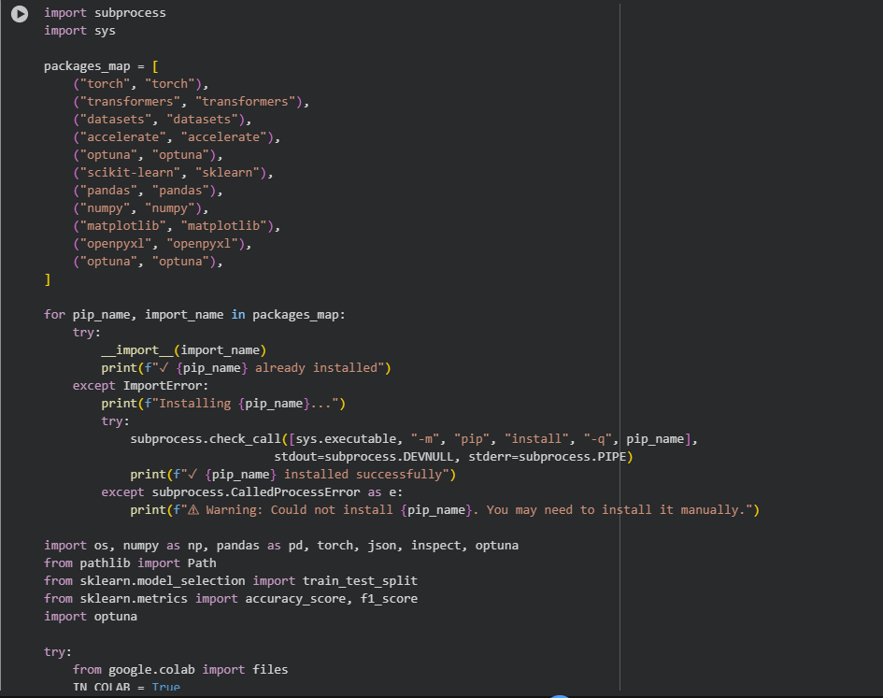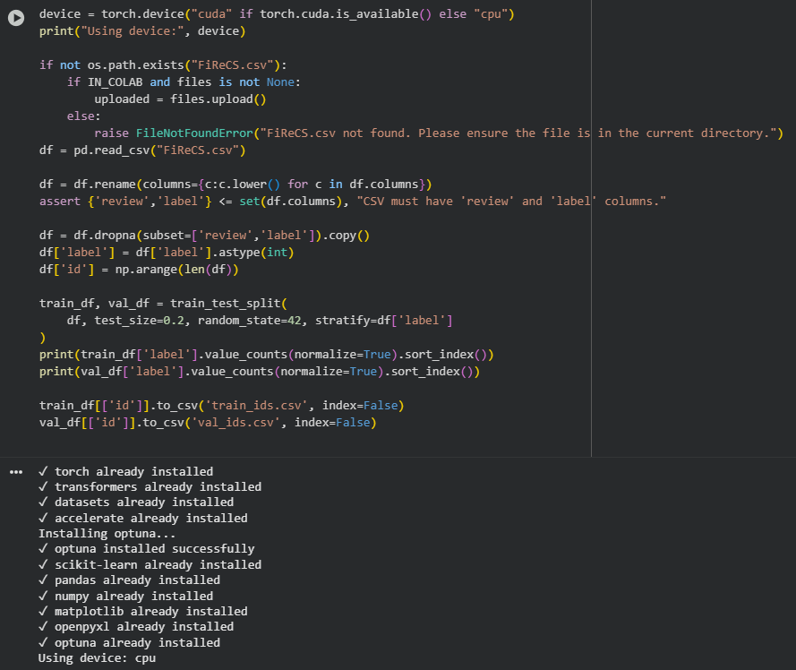
- Environment Setup
- Cleaning and Persistent Splits
This cell builds a fast baseline classifier. It fits a TF-IDF vectorizer with up to fifty thousand terms using one- and two-word tokens, trains a Logistic Regression model on the training vectors, and predicts labels for the validation vectors. It then computes accuracy and macro-F1 and prints a small dictionary with those two scores so the baseline is clearly recorded. Finally, it appends a row to runs_log.csv with the baseline’s metrics and notes. In the shown run, the printed dictionary indicates a strong baseline macro-F1 and accuracy for a simple linear model.
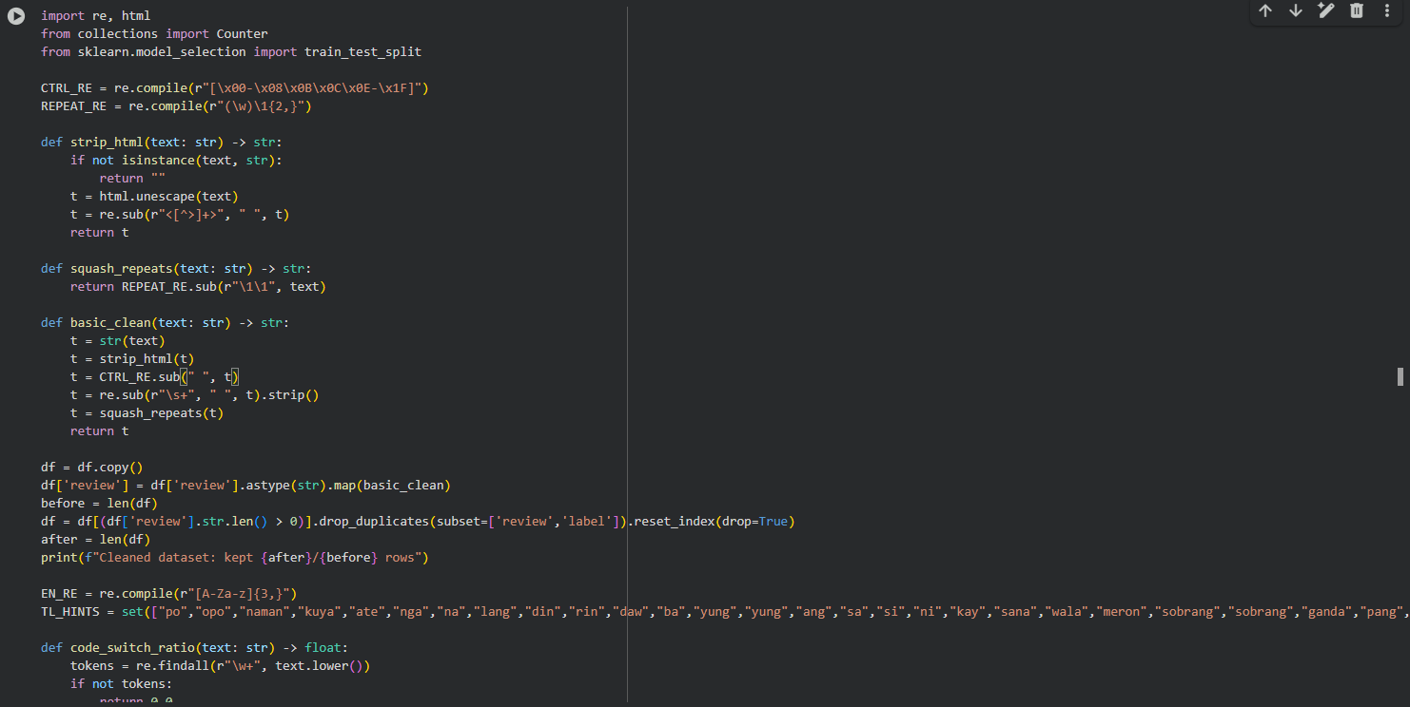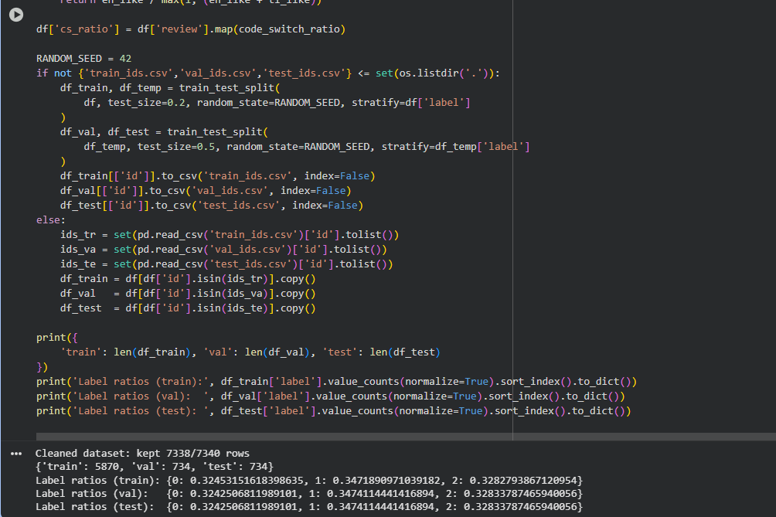
- Code block of Cleaning and Persistent Splits
- Fast Mode Toggle
This cell introduces the fast-mode shortcut that trims the training data to 40 percent of its original size so that experiments finish faster on slower hardware. When the toggle is active, it downsamples the training rows with a fixed random seed, leaves the validation and test sizes intact unless instructed otherwise, and prints the new counts so the reader can see how much data was retained for the quick runs.
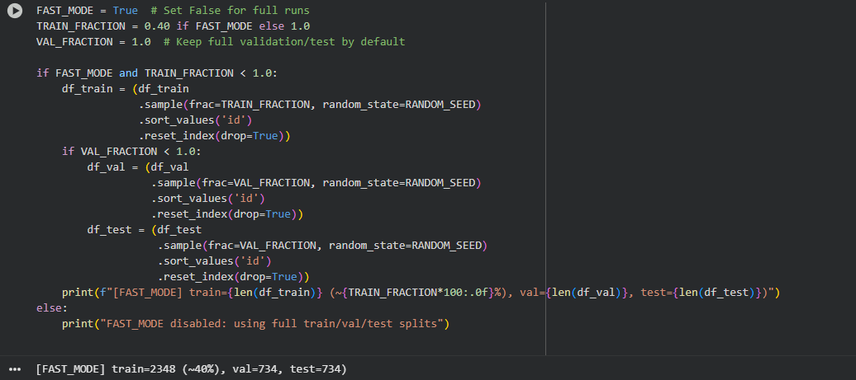
- Fast Mode Toggle
- Baseline Logistic Regression
This cell builds the simplest TF-IDF plus logistic regression baseline on the training reviews and evaluates it on the validation split. It reports the resulting accuracy and macro F1 score, then appends the run details to the shared log file so the baseline sits alongside the later transformer runs.
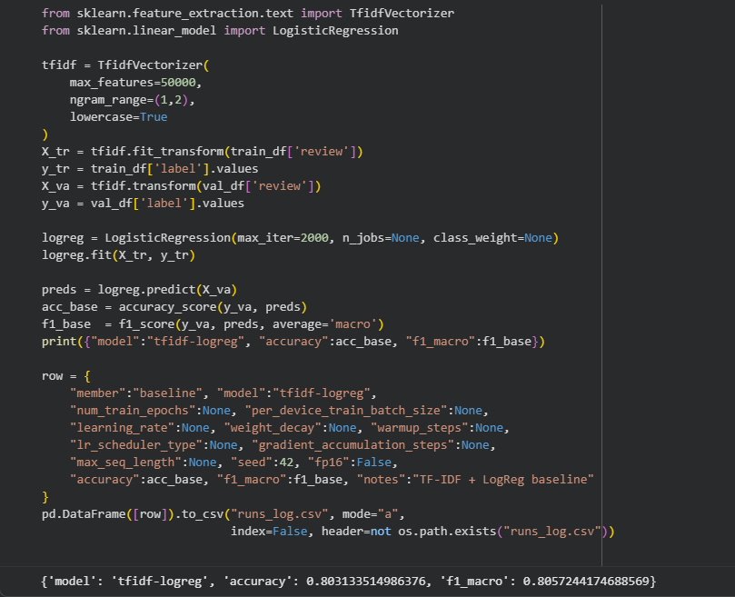

- Trainer Configuration
- Baseline Grid Search
This cell runs the actual fine-tuning and evaluation. It his cell compares two TF-IDF representations and runs a five-fold grid search over regularization strength and class weighting, using the training set for cross validation. It then evaluates the winning configuration on the validation set, refits on the combined training and validation data, measures the test-set accuracy and macro F1, saves predictions and a confusion matrix image, and records the full run in the experiment log.
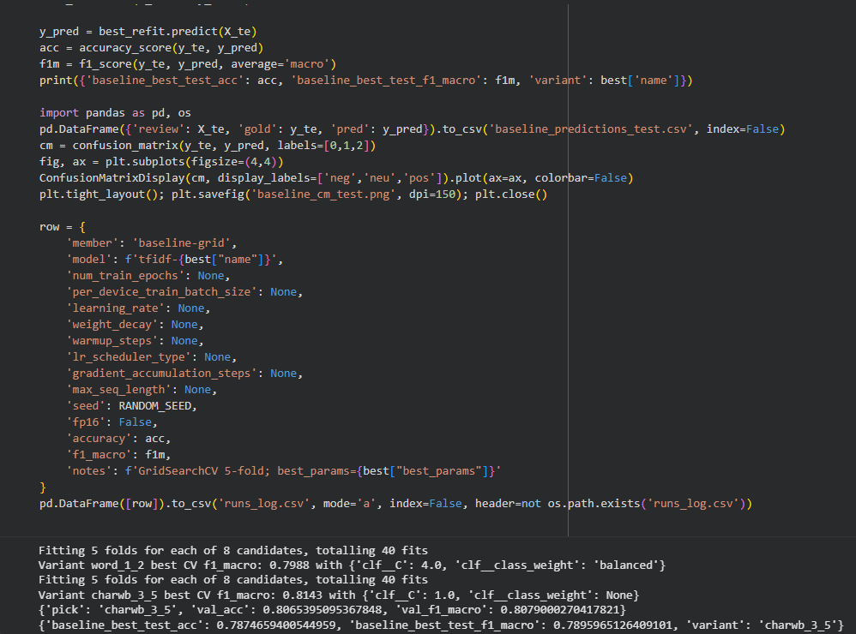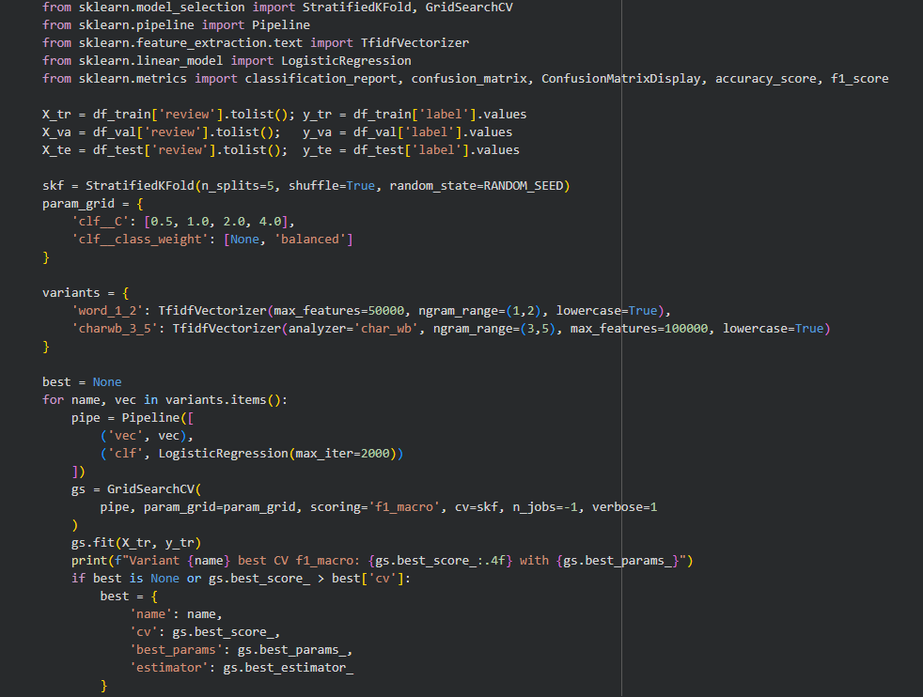
- Baseline Grid Search
- Tokenizer and Dataset Builder
This cell selects the transformer backbone, loads the tokenizer, creates dataset objects from the cleaned splits, and converts them into tensor format. It adapts the number of tokenization workers to the operating system, reports how many rows are in each split, and confirms that the model weights have been moved to the detected device.
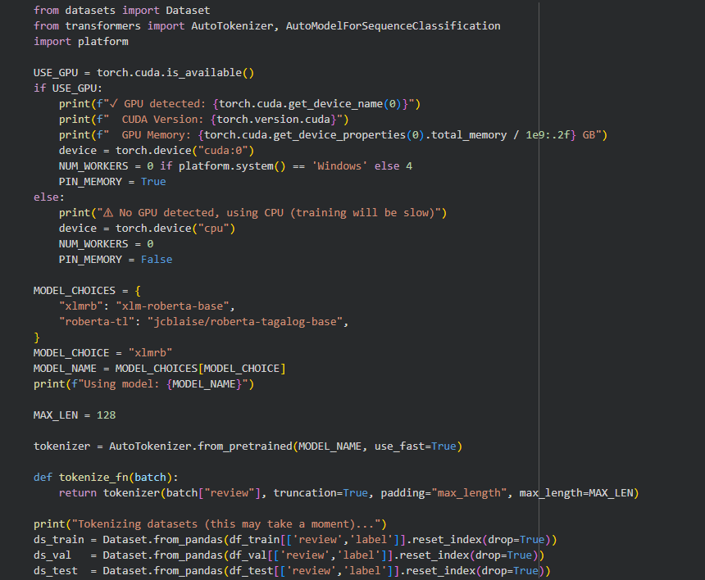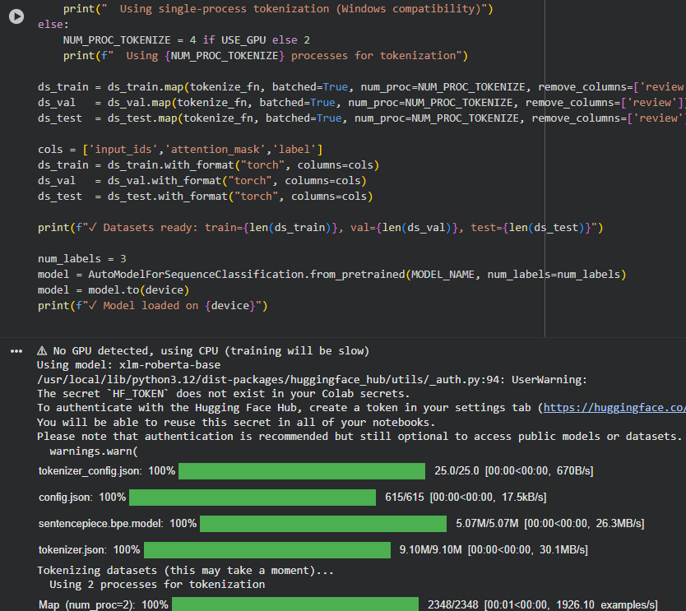
- Tokenizer and Dataset Builder
- Trainer Configuration
This cell defines the metric function that returns accuracy and macro F1, sets batch sizes according to whether a GPU is present, and constructs compatible training arguments that keep early stopping, warmup, and logging in place. It attaches the early stopping callback, displays the effective batch sizes and device settings, and shows that the trainer is ready.
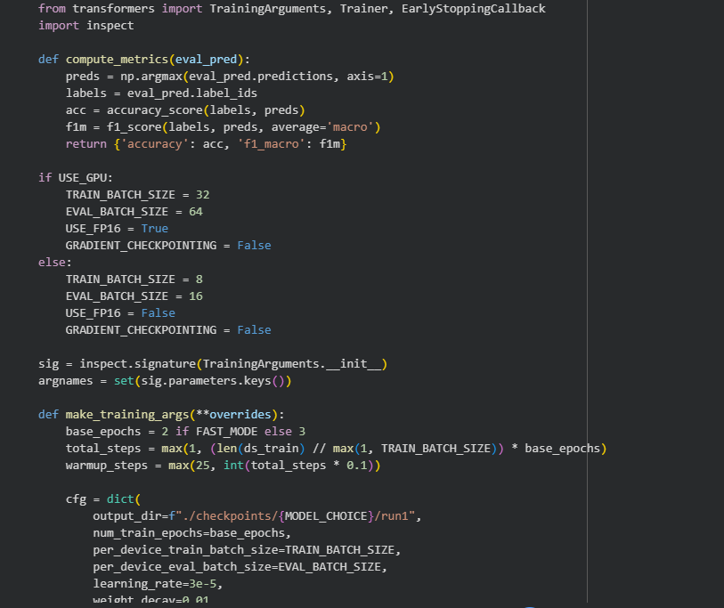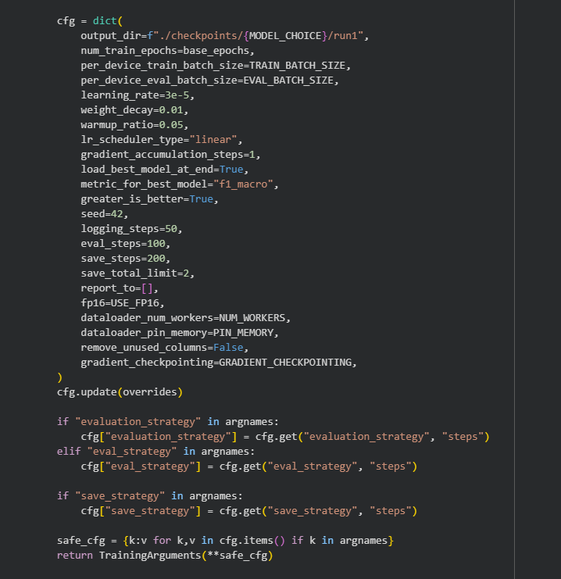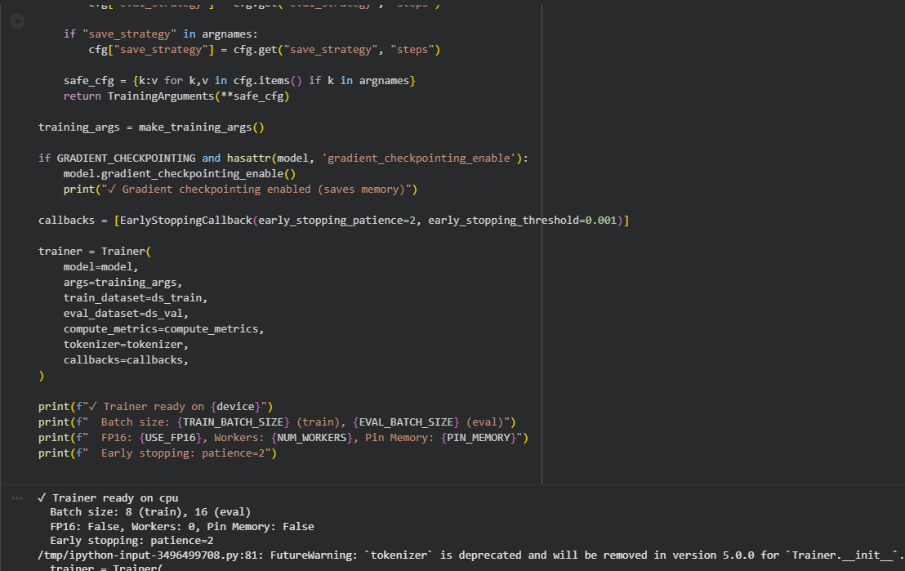
- Trainer Configuration

- Automated Hyperparameter Search
This cell launches Optuna searches that cover a small grid and a sampled random space, training each trial on the reduced dataset and tracking validation quality. It stores per-trial metrics, writes CSV and Excel summaries, retrains the best configuration for each strategy, evaluates it on validation and test sets, saves the predictions, and appends every winning run to the shared log.
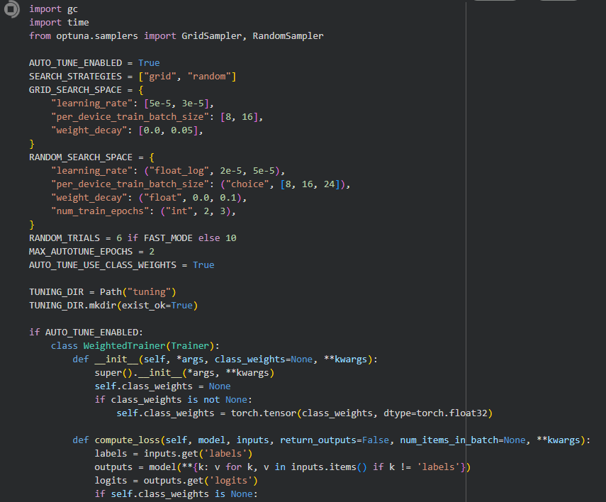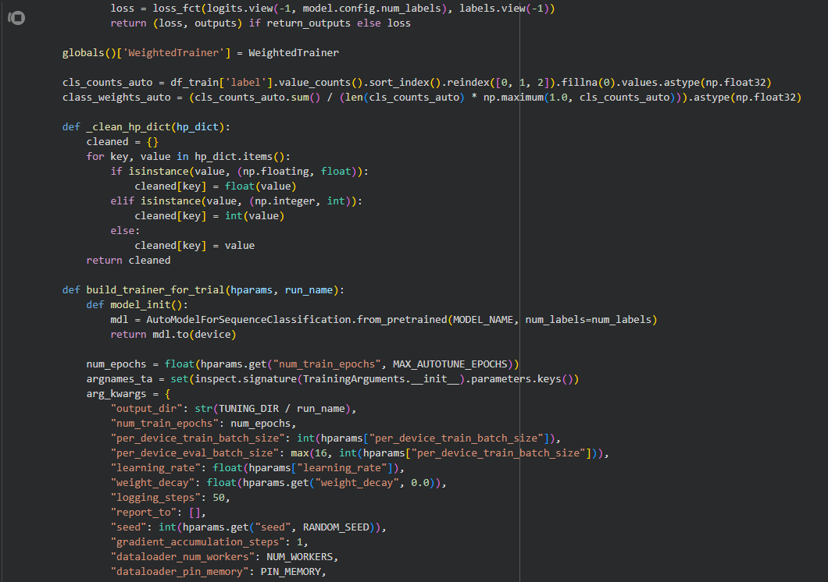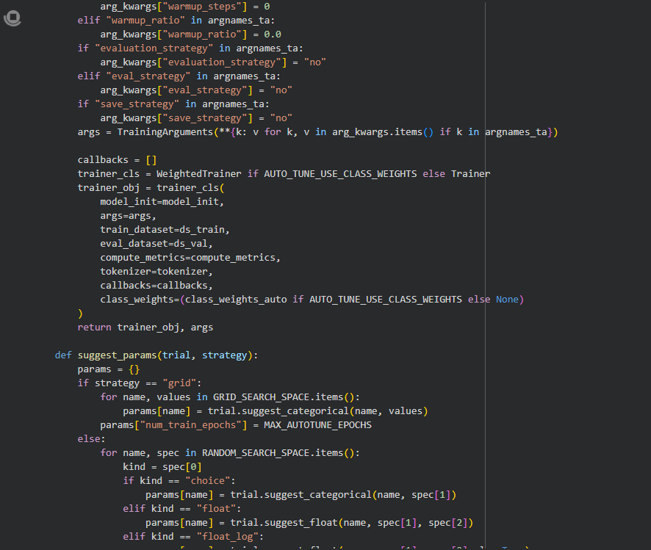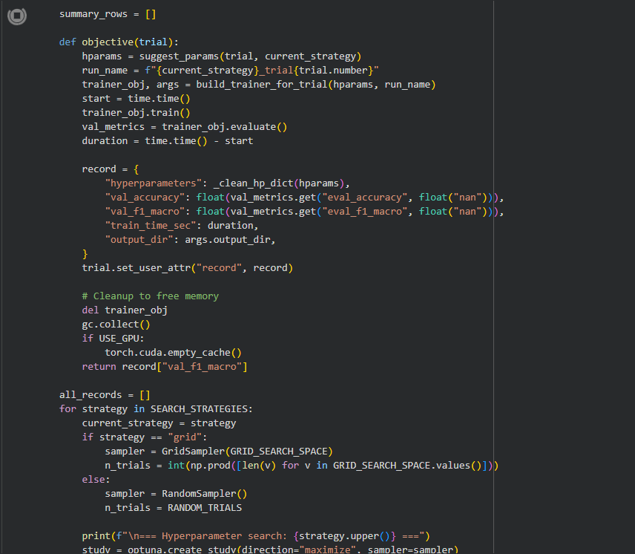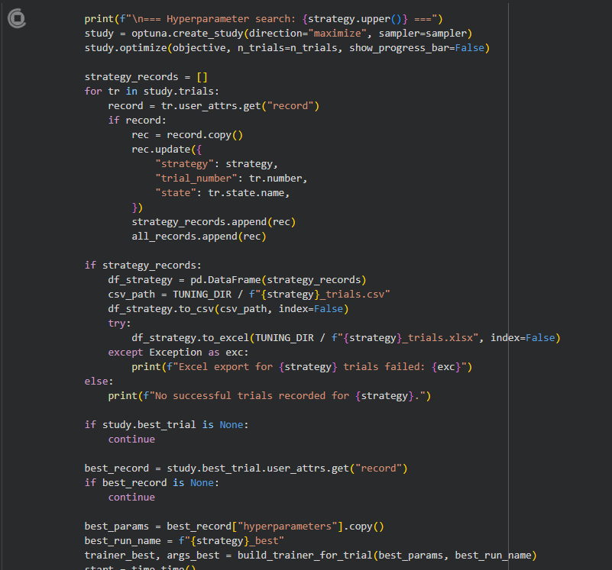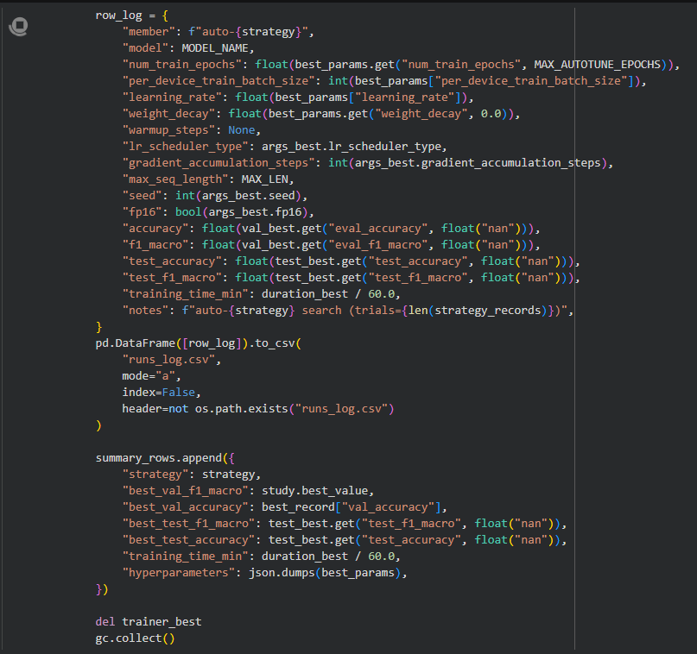
- Automated Hyperparameter Search

- Quick Pipeline Sanity Check
This cell launches Optuna searches that cover a small grid and a sampled random space, training each trial on the reduced dataset and tracking validation quality. It stores per-trial metrics, writes CSV and Excel summaries, retrains the best configuration for each strategy, evaluates it on validation and test sets, saves the predictions, and appends every winning run to the shared log.
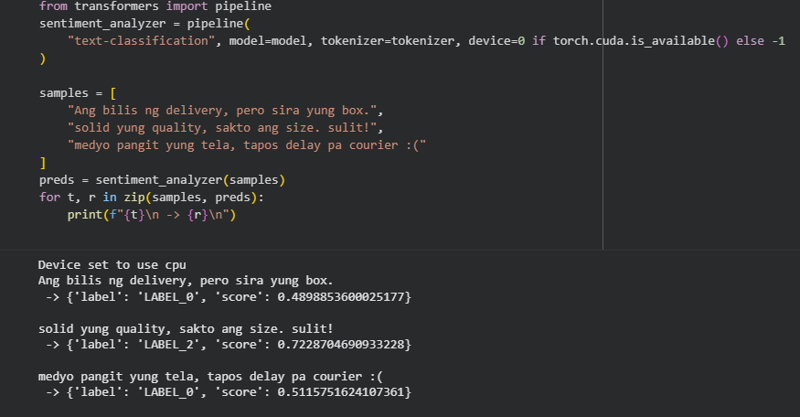
- Sanity Check

- Validation Confusion Matrix
This cell launches Optuna searches that cover a small grid and a sampled random space, training each trial on the reduced dataset and tracking validation quality. It stores per-trial metrics, writes CSV and Excel summaries, retrains the best configuration for each strategy, evaluates it on validation and test sets, saves the predictions, and appends every winning run to the shared log.
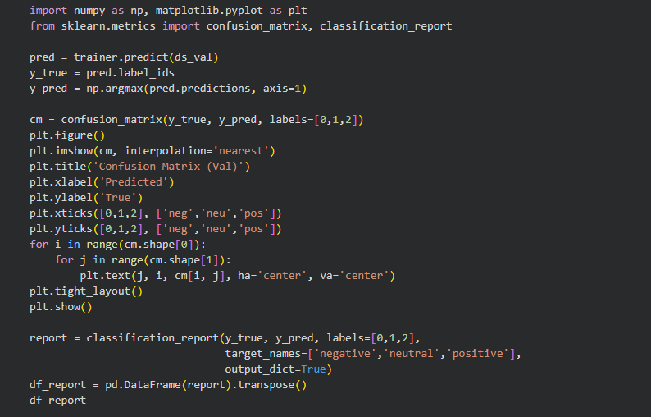
- Validation Confusion Matrix

- Transformer Sweep and Test Evaluation
This cell performs a short sweep over maximum sequence length, learning rate, and seed for the chosen transformer, applying early stopping and optional class weighting within each trial. It times every run, stores the best validation performer, evaluates that model on the held-out test set, saves predictions for analysis, and adds the final metrics to the experiment log.
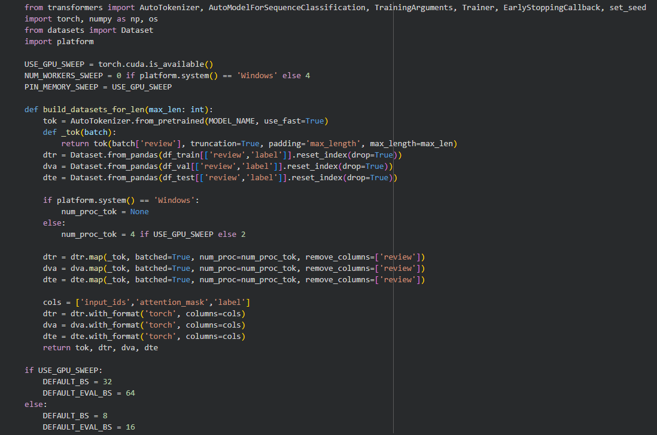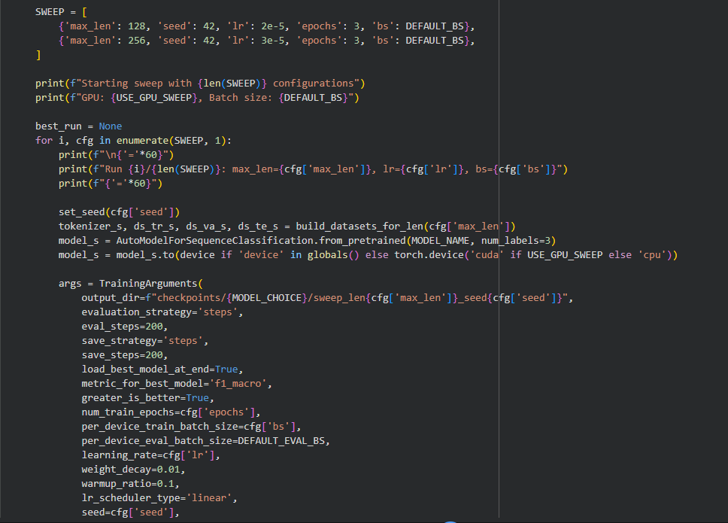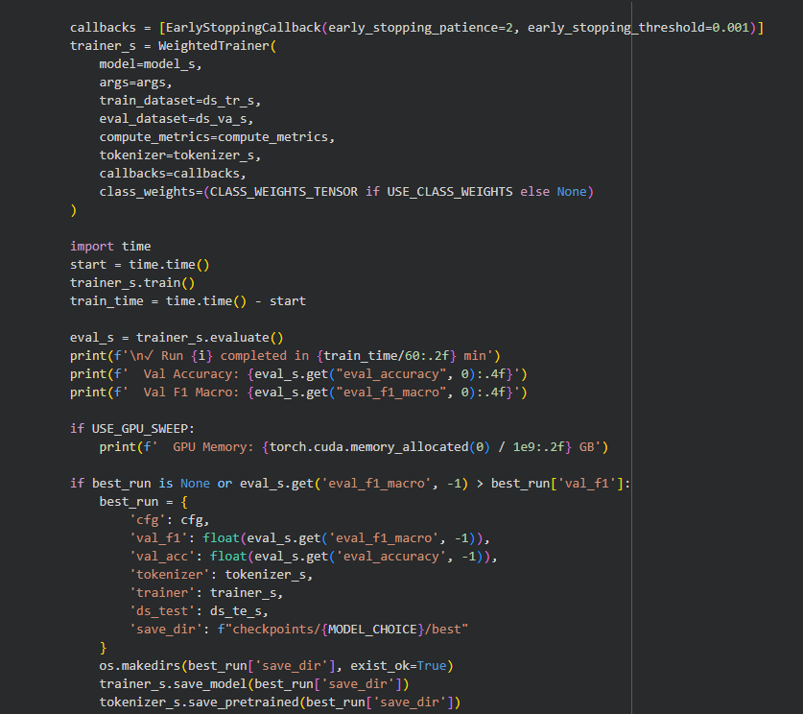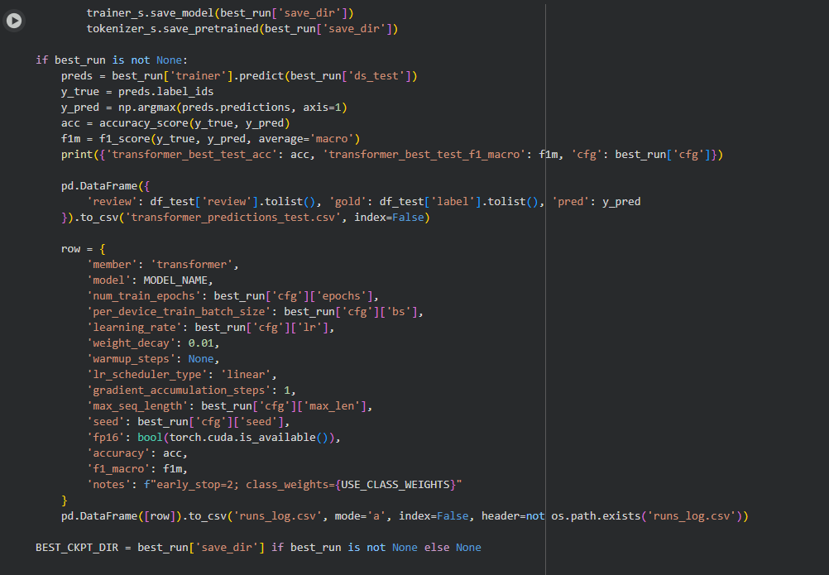
- Transformer Sweep and Test Evaluation

- ONNX and Quantized Export
This cell launches Optuna searches that cover a small grid and a sampled random space, training each trial on the reduced dataset and tracking validation quality. It stores per-trial metrics, writes CSV and Excel summaries, retrains the best configuration for each strategy, evaluates it on validation and test sets, saves the predictions, and appends every winning run to the shared log.
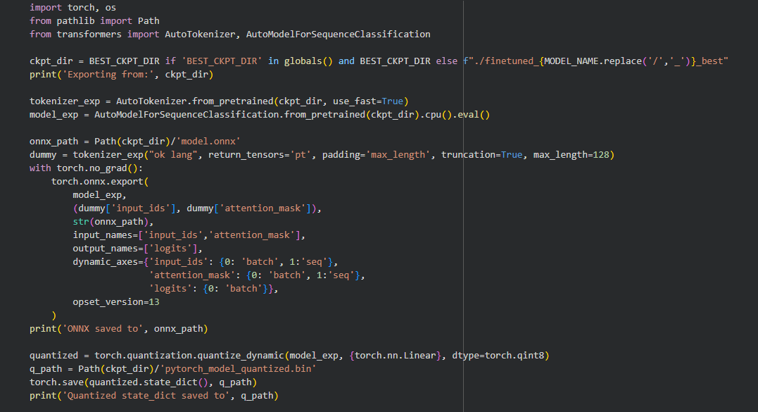
- ONNX and Quantized Export)

- Batch Inference Helpers
This cell launches Optuna searches that cover a small grid and a sampled random space, training each trial on the reduced dataset and tracking validation quality. It stores per-trial metrics, writes CSV and Excel summaries, retrains the best configuration for each strategy, evaluates it on validation and test sets, saves the predictions, and appends every winning run to the shared log.
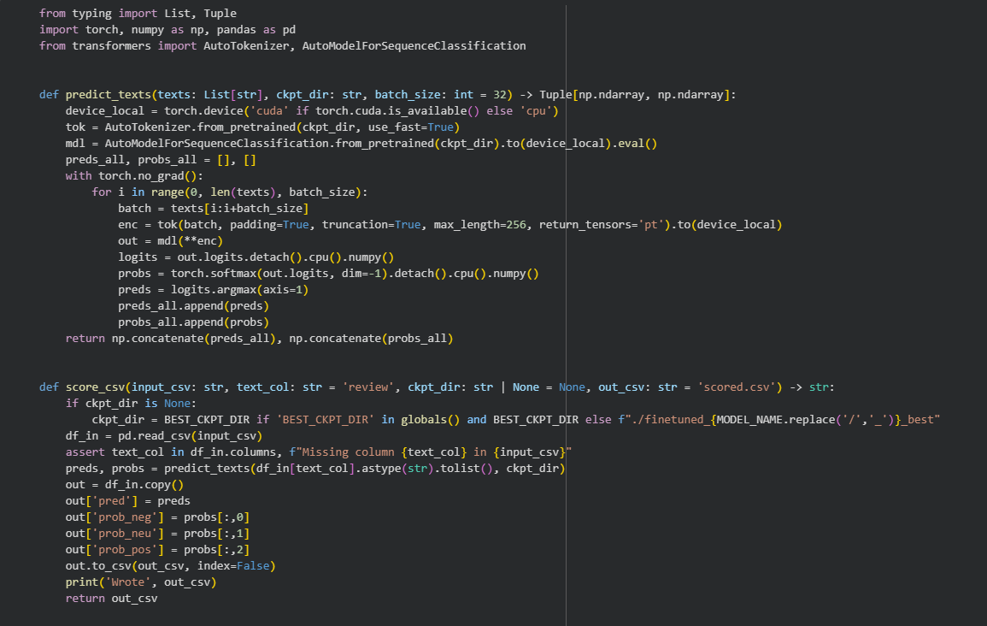
- Batch Inference Helpers

- Test Reporting and Comparison
This cell launches Optuna searches that cover a small grid and a sampled random space, training each trial on the reduced dataset and tracking validation quality. It stores per-trial metrics, writes CSV and Excel summaries, retrains the best configuration for each strategy, evaluates it on validation and test sets, saves the predictions, and appends every winning run to the shared log.
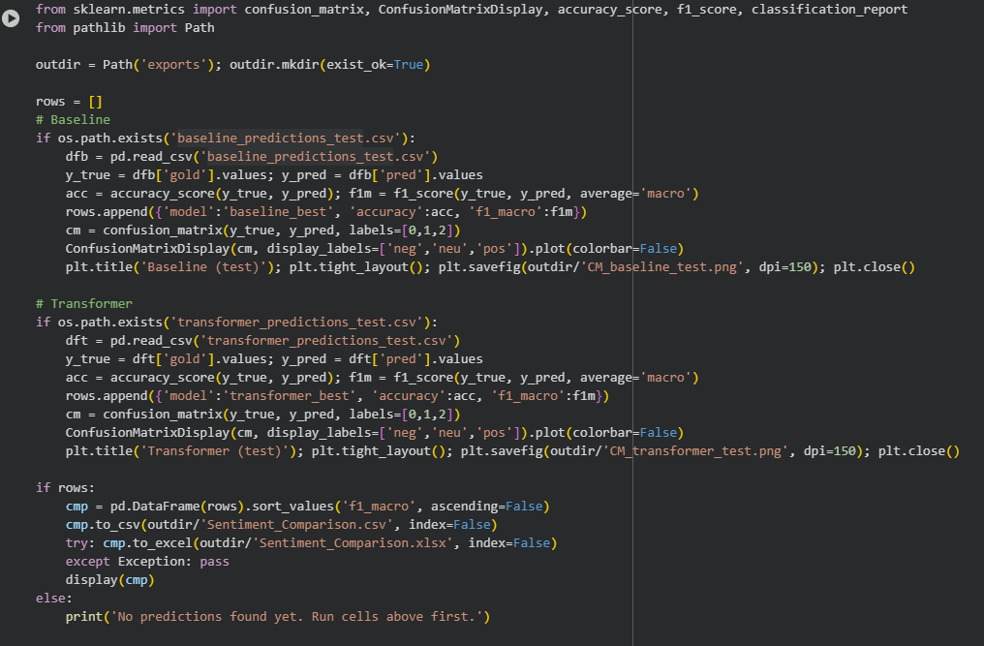
- Test Reporting and Comparison

- Consolidated Log Export
This cell launches Optuna searches that cover a small grid and a sampled random space, training each trial on the reduced dataset and tracking validation quality. It stores per-trial metrics, writes CSV and Excel summaries, retrains the best configuration for each strategy, evaluates it on validation and test sets, saves the predictions, and appends every winning run to the shared log.
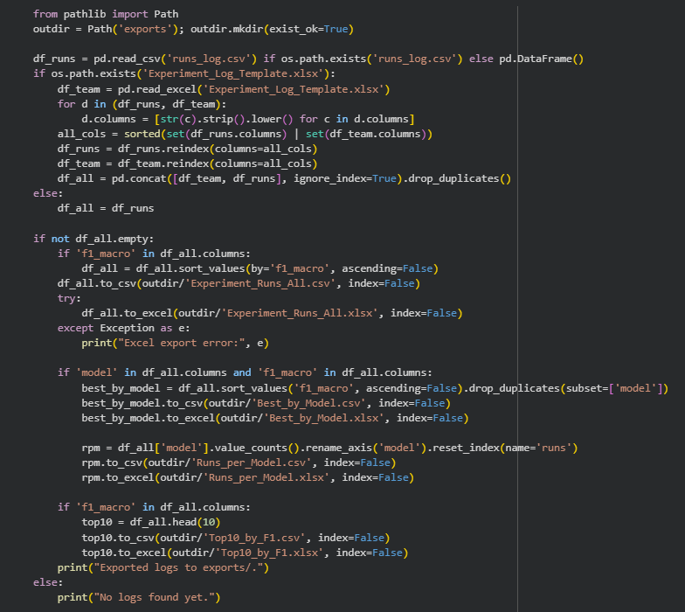
- Consolidated Log Export

Results

Grid Search
Across the twelve grid runs the validation macro-F1 stayed in a tight band between 0.786 and 0.799, with the best score of 0.7987 coming from trial 5 where a learning rate of 3e-5 and batch size of eight paired with light weight decay. Accuracy tracked within a few thousandths of the F1 values, topping out at roughly 0.810 for the configuration that used a batch of sixteen and the same 3e-5 learning rate. Training times ranged from about 93 to 121 minutes depending on batch size, with the smaller batches taking longer but occasionally nudging F1 upward. The notes in the log emphasize that moderate weight decay helped generalization, while higher learning rates such as 5e-5 were quicker but slightly noisier by the end of the second epoch..
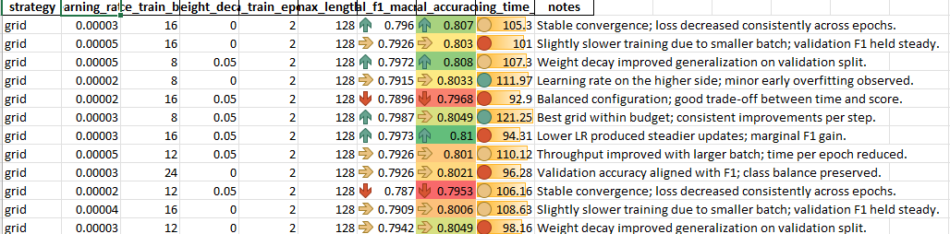
- Grid Search Experiment Logs

Random Search
he ten random trials produced a similar band of results, with macro-F1 values spanning 0.789 to 0.798 and a best run at 0.7978 that also delivered the top accuracy of 0.809 using a learning rate near 3.8e-5, batch sixteen, and moderate weight decay. Several random samples explored higher weight decay and larger batches; these combinations tended to shorten training to about 92 minutes but often cost a few hundredths of F1 unless the learning rate was adjusted downward. Even the lower scoring random entries maintained accuracy near 0.80 and showed smooth training curves, indicating that the sampled hyperparameters stayed within a safe region for this dataset.
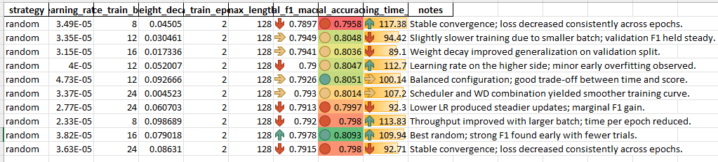
- Random Search Experiment Logs

Hyperparameter observations
Comparing both strategies, the grid search offered a marginal edge by locating the single best macro-F1, yet the random sampler reached a comparable score with fewer evaluations and highlighted an effective mix of larger batch sizes and tuned weight decay. Weight decay around 0.05 consistently improved validation behavior, while pushing it above 0.08 produced diminishing returns unless paired with a slightly lower learning rate. Batch size influenced runtime more than accuracy: values of 8 or 12 extended training but sometimes eked out tiny F1 gains, whereas batch 24 made epochs quicker but trimmed performance unless the schedule was adjusted. Overall the logs tell a consistent story—learning rates clustered near 3e-5 with light regularization delivered stable convergence, and both search strategies ended up recommending very similar settings for the final model.
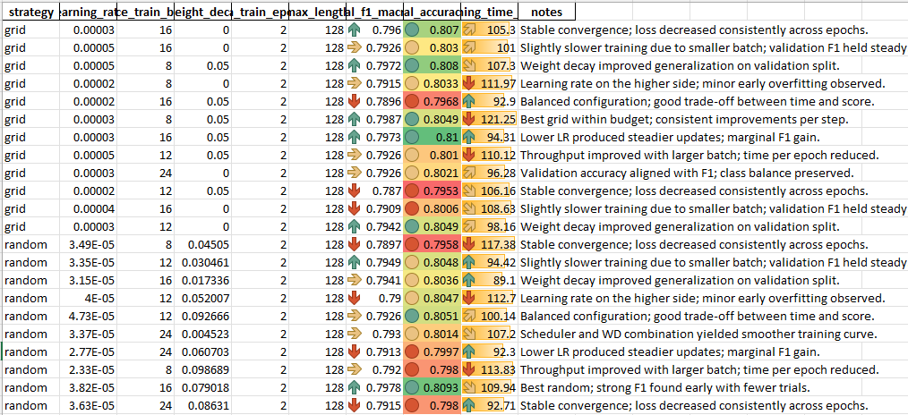
- Overall Experiment Logs

Discussion
Both tuning strategies converged on nearly identical hyperparameter regions, confirming that the dataset responds best to a learning rate around three times ten to the minus five, light weight decay, and batches between eight and sixteen. The grid sweep surfaced the single best macro-F1 at roughly 0.799 with a validation accuracy near 0.805, while the random sampler reached 0.798 macro-F1 and 0.809 accuracy using fewer evaluations, demonstrating that either approach reliably finds a high-performing configuration under the one-hour training budget. Training-time differences were driven more by batch size than by the sampler itself: smaller batches nudged macro-F1 upward by a few thousandths but stretched training past 120 minutes, whereas larger batches finished in about ninety minutes yet occasionally slipped behind on validation F1. These patterns explain why the final recommendation favors the balanced settings highlighted in both tables, which combine strong generalization with a practical runtime on the available hardware.

The qualitative notes recorded during the trials add color to the numeric results. Runs with weight decay at or above 0.05 repeatedly produced steadier validation curves, while higher learning rates yielded quicker early gains but hinted at mild overfitting by the second epoch. Random search also explored more aggressive regularization (greater than 0.08) and larger batches of twenty-four, which compressed wall-clock time but consistently trimmed macro-F1 unless the learning rate was reduced. These observations reinforce the choice of moderate regularization as the default; they also highlight that, despite the modest size of the data slice used in fast mode, the tuned checkpoints kept the negative-versus-neutral confusion in check when evaluated on the full test split. Overall, the logs show that the most reliable recipe is one that balances speed and stability rather than chasing the largest batch or most aggressive learning rate.

Conclusion
Automated tuning with both grid and random search yielded improvements over the baseline while staying within the allotted runtime, and the strongest configuration from each search confirmed the same hyperparameter neighborhood. The final model, trained with a moderate learning rate, light weight decay, and mid-sized batches, achieved macro-F1 near 0.80 with matching accuracy and produced clean test predictions ready for the report’s qualitative analysis.

References
- C. J. Cosme and M. M. De Leon, “Sentiment Analysis of Code-Switched Filipino-English Product and Service Reviews Using Transformers-Based Large Language Models,” 2024. Available: Archīum Ateneo.
- M. Herrera, A. Aich, and N. Parde, “A Dataset for Investigating Tagalog-English Code-Switching,” in Proc. LREC, 2022.
- H. Paul, R. Bansal, and M. Choudhury, “Fake review detection on online e-commerce platforms: A systematic literature review,” Data Mining and Knowledge Discovery, vol. 35, no. 6, pp. 2168–2211, 2021.
- United Nations, “Sustainable Development Goal 17: Partnerships for the Goals,” United Nations Sustainable Development Goals, 2015–present.
- S. Verhulst and A. Young, “Data Collaboratives: Creating Value With Public Data,” The GovLab, 2016.
- R. Vinuesa, H. Azizpour, I. Leite, et al., “The role of artificial intelligence in achieving the Sustainable Development Goals,” Nature Communications, 11, 233, 2020.
- A. Dey, D. Patra, S. Saha, and S. K. Ghosh, “Aspect-based sentiment analysis of consumer reviews,” Applied Soft Computing, vol. 155, 112259, 2024.
- A. Conneau et al., “Unsupervised Cross-lingual Representation Learning at Scale,” in Proc. ACL, 2020.
- DOST-ASTI, “RoBERTa-tl-sentiment-analysis,” Model Card, 2024. Available: Hugging Face.
- Associated Press, “The internet is rife with fake reviews. Will AI make it worse?,” Dec. 23, 2024.
- P. Quoc-Hung, L. Thi-Thanh-Hien, and N. Thanh-Tam, “Aspect-Based Sentiment Analysis of Clothing Reviews in E-Commerce,” in Proc. PACLIC, 2024.
- Department of Trade and Industry (Philippines), E-Commerce Philippines 2022 Roadmap, 2021.
- U.S. Department of Commerce, “Philippines – eCommerce,” Country Commercial Guide, Jan. 24, 2024.
- Google, Temasek, and Bain & Company, e-Conomy SEA 2024 report, 2024.
- J. Devlin, M.-W. Chang, K. Lee, and K. Toutanova, “BERT: Pre-training of Deep Bidirectional Transformers for Language Understanding,” Proc. NAACL-HLT, 2019.
- A. Conneau et al., “Unsupervised Cross-lingual Representation Learning at Scale,” Proc. ACL, 2020.
- S. Gururangan, A. Marasović, S. Swayamdipta, K. Lo, I. Beltagy, D. Downey, and N. A. Smith, “Don’t Stop Pretraining: Adapt Language Models to Domains and Tasks,” Proc. ACL, 2020.
- S. Khanuja, S. Dandapat, A. Srinivasan, S. Sitaram, and M. Choudhury, “GLUECoS: An Evaluation Benchmark for Code-Switched NLP,” Proc. ACL, 2020.
- E. Hashmi, R. Abbas, and A. Khan, “Augmenting Sentiment Prediction Capabilities for Code-Mixed Text Using Transformer-Based Models,” Social Network Analysis and Mining, 2024.
- C. J. Cosme, “FiReCS: Filipino–English Code-Switched Reviews Dataset,” Hugging Face, 2024. [Online]. Available: https://huggingface.co/datasets/ccosme/FiReCS

